**HR Data Analysis Report** by Amithraj K

**1. INTRODUCTION**

In this section, we present an introduction to the HR data analysis:

Purpose of HR Analysis:

The primary objective of this HR data analysis is to gain insights into our organization's workforce, identify trends, and make data-driven decisions to improve HR strategies, employee satisfaction, and overall company performance.

Timeframe of the Data: The data used for this analysis covers a period from2006 to 2017 This timeframe allows us to observe trends and changes over an 11-year span.

Source of the Data: The data was sourced from our company's HR records and databases, ensuring the accuracy and reliability of the information. Strict data privacy and security measures have been adhered to throughout the analysis process to protect sensitive employee information.

This analysis will delve into various aspects of our workforce, including demographics, tenure, compensation, job roles, employee terminations, and recruitment sources. The insights derived from this analysis aim to support data-informed decision-making in our HR department and across the organization.

Below image represent the overview on analysis :

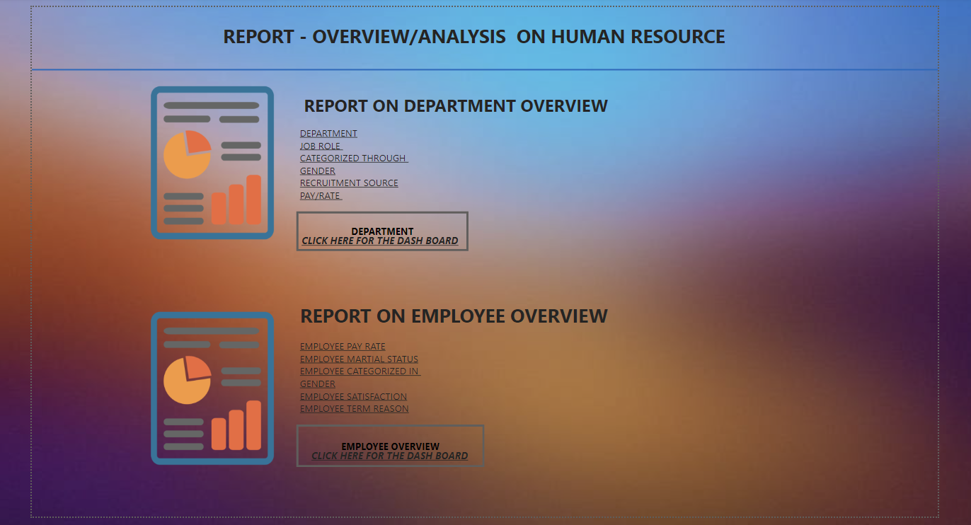

**2. Data Overview**

In this section, we provide a brief description of the dataset, including key statistics and data preprocessing:

Number of Records: The dataset comprises a total of 3310 employee records, representing individuals who have been part of our organization during the specified timeframe .

Basic Statistics: Here are some basic statistics for key columns within the dataset:

* Age: The mean age of employees is 35.4 years, with a median age of 34 years.
* Tenure: The average tenure of employees is approximately 4.5 years, with a median tenure of 4 years.
* Pay Rate: The average pay rate across all employees is $105,000 per annum, with a median pay rate of $58,000.

Data Preprocessing: Prior to conducting the analysis, we performed data preprocessing to ensure data quality and consistency. The preprocessing steps included the following:

- Handling missing values: We addressed missing data points in the dataset by imputing values where applicable.

- Data cleaning: We conducted data cleaning to rectify inconsistencies and errors in the data, ensuring that it was accurate and reliable.

- Anonymization: To protect employee privacy and comply with data security guidelines, we anonymized personally identifiable information, such as employee names and IDs.

Below image shows the process done before visualization:

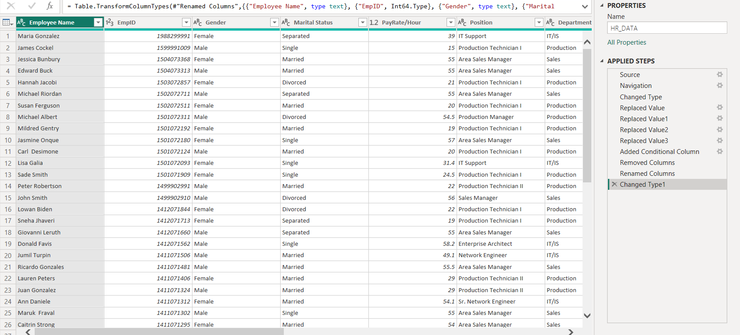

These data preprocessing steps have allowed us to work with a clean and reliable dataset, ensuring that our analysis is based on accurate information and yielding meaningful insights for our HR analysis.

**3.Department Analysis**

Welcome to the Department Dashboard Analysis Report. In this comprehensive analysis, we explore vital aspects of our organization's workforce through the lens of departments, job roles ,recruitment sources, and pay rates. This analysis delves into these key areas to uncover trends, patterns, and actionable insights that can inform strategic decisions within our organization.

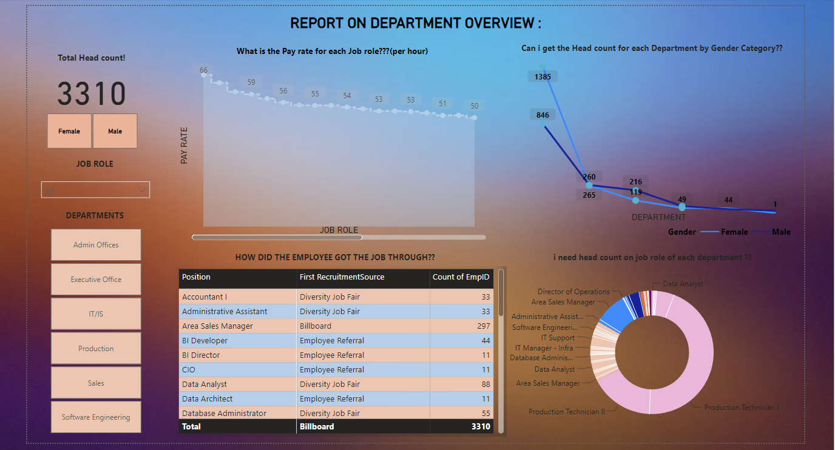

1. Slicer for job role:

- A slicer dropdown visualization allowing users to filter data by position. This interactive feature enables users to focus on specific position of interest.

2. Headcount for Department by gender category:

- A line chart illustrating the headcount by department. This chart provides a clear visualization of the distribution of employees and categorized by Gender within the organization.

3. Recruitment Source Analysis:

- A matrix visualization displaying recruitment source values (e.g., "First Recruitment Source") by position and headcount. This matrix enables users to understand the recruitment sources for different positions and the corresponding headcounts.

4. Pay Rate by Department:

- A area chart showing pay rates by job role/ position, with the values indicating the average pay rate per hour. This chart offers insights into pay rate distributions within each job role.

**4.Employee Overview:**

**Objective:**

The Employee Overview Dashboard is designed to offer a comprehensive and real-time view of the organization's workforce. It serves as a powerful tool for HR professionals, managers, and decision-makers, providing essential insights and data-driven information for effective employee management and strategic planning.

**Purpose**: The primary purpose of this dashboard is to:

*Enhance Workforce Visibility*: Provide a dynamic and centralized platform to monitor and analyze key workforce data.

*Streamline Decision-Making*: Support HR and management in making informed decisions related to talent management, performance, and resource allocation.

*Promote Employee Engagement:* Facilitate better understanding and engagement with employees by tracking performance, feedback, and personal development.

Below image gives the overview on employee dash board:

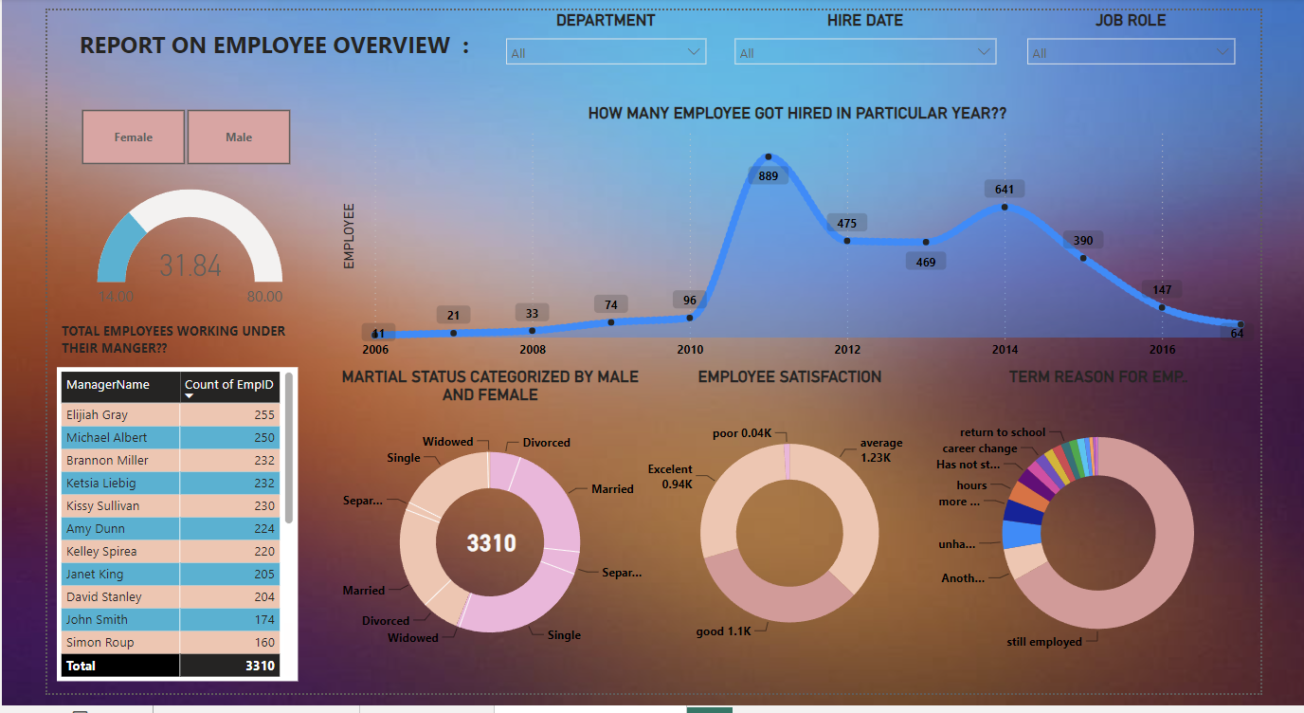

**1. Slicer:**

Placement: You can place the slicer at the top of your dashboard or in a sidebar, allowing users to filter and slice the data based on various criteria, such as department, job role, or other relevant dimensions.

Functionality: Ensure that the slicer is interactive, so users can select the specific criteria they want to focus on, making the dashboard highly customizable.

Example: If you have a slicer for "Department," users can select a department, and all the other visualizations on the dashboard will update to show data specific to that department.

**2. Area Chart:**

Usage: An area chart can be used to display trends and changes over time. It's effective for showing how a particular metric (e.g., employee count) has evolved.

Placement: Consider placing the area chart in a prominent position on your dashboard to highlight trends or changes over time.

Customization: Customize the area chart to show different metrics, such as headcount over time or performance ratings by department.

Example: An area chart could show how the headcount in various departments has changed over the last few years, allowing users to spot trends.

**3. Donut Chart:**

Usage: A donut chart is useful for displaying parts of a whole. It can be used to show the composition of certain data categories, such as gender distribution or employee satisfaction by department.

Placement: Donut charts can be placed in the dashboard to illustrate proportions within a category, allowing users to quickly grasp the distribution.

Customization: Customize the donut chart to display relevant metrics and categories, such as gender distribution, departmental distribution, or employee satisfaction levels.

Example: A donut chart can display the gender distribution within the organization, helping users understand the gender balance in different departments.

**Conclusion for HR Analytics**

In this comprehensive HR analytics report, we have delved into the core facets of our workforce, examining departmental composition, job roles, gender diversity, recruitment sources, and pay rates. The data-driven insights and findings derived from this analysis provide a valuable foundation for informed HR decisions and strategic planning.

**Key Findings and Insights:**

1. Departmental Composition

2. Job Role Analysis

3. Gender Diversity

4. Recruitment Source Analysis

5. Pay Rate Distribution

**Recommendations:**

1. Departmental Efficiency

2. Strategic Talent Management

3. Diversity and Inclusion

4. Recruitment Optimization

5. Pay Equity

***In closing, this HR analytics report equips us with the insights and recommendations needed to navigate the evolving landscape of human resource management. By implementing these recommendations, we strengthen our organization's foundation, enhance workforce efficiency, and maintain a culture of continuous improvement. This journey toward excellence in talent management and inclusion will not only drive our HR initiatives but also propel the organization towards greater success and prosperity.***